ECG Arrhythmia Detection Using 2D CNN Model

Project Overview:
This comprehensive report outlines a project that focuses on the detection of arrhythmia within electrocardiogram (ECG) signals using Convolutional Neural Networks (CNNs). The primary objective is to showcase the efficacy of CNNs in accurately identifying distinct arrhythmia patterns. The project leverages the MIT-BIH Arrhythmia Database, an extensive dataset comprising 109,446 ECG signal samples, providing a robust foundation for the investigation.
Objectives:
The central aim of the project is to demonstrate the effectiveness of 2D CNN models in the nuanced task of identifying various arrhythmia patterns present in ECG signals. By employing advanced deep learning techniques, the project seeks to contribute to the development of reliable and automated arrhythmia detection systems.
Dataset Utilization:
The MIT-BIH Arrhythmia Database serves as a cornerstone, offering a rich collection of 109,446 ECG signal samples. These samples represent a diverse array of cardiac conditions, categorized into five specific arrhythmia types. The utilization of this dataset ensures that the model is exposed to a wide range of cardiac anomalies, fostering its capacity to accurately discern different arrhythmias.
Significance of 2D CNNs:
Convolutional Neural Networks (CNNs) are chosen as the primary modeling approach due to their proven success in image classification tasks and their ability to capture spatial dependencies within data. In this context, the 2D CNN architecture is adapted to process the temporal nature of ECG signals, with the anticipation that it will excel in recognizing intricate patterns indicative of various arrhythmias.
Project Phases:
The project is divided into several key phases, starting with data pre-processing, where raw ECG signals from CSV files are loaded and manipulated to ensure optimal model training conditions. Addressing class imbalance is a critical step, employing resampling techniques to handle variations in the representation of different arrhythmia types. Additionally, data augmentation techniques, such as introducing Gaussian noise, are incorporated to enhance the model's ability to generalize to real-world scenarios.
Dataset Overview:
1. Source: Physionet's MIT-BIH Arrhythmia Dataset
The dataset's origin from Physionet's MIT-BIH Arrhythmia Dataset establishes a robust foundation, drawing from a widely recognized repository in biomedical signal processing. Physionet's reputation for providing high-quality data for research, particularly in the specialized domain of arrhythmia detection, lends credibility to the dataset. Researchers and practitioners often turn to this source due to its reliability, ensuring that the data utilized in this project adheres to established standards in the field.
2. Number of Samples: 109,446
The dataset comprises an extensive collection of 109,446 samples, each representing a unique recording of an electrocardiogram (ECG) signal. This abundance of data is instrumental in facilitating a comprehensive exploration of various arrhythmia patterns. The sheer volume of instances ensures that the proposed 2D CNN model encounters a diverse range of cardiac scenarios during training, contributing to its ability to generalize well. Additionally, the ample number of samples reinforces the statistical robustness of the model's evaluation.
3. Number of Categories: 5 (N, S, V, F, Q)
The dataset is strategically categorized into five distinct classes, each denoted by a specific label: N, S, V, F, and Q. These categories likely represent different types of arrhythmias or normal cardiac activity. The inclusion of multiple categories is pivotal in enriching the model's learning experience. By exposing the model to diverse arrhythmia patterns and normal cardiac behaviors, it becomes adept at distinguishing between different classes. This categorization aligns seamlessly with the project's overarching goal of achieving effective arrhythmia detection.
4. Sampling Frequency: 125Hz
The ECG signals in the dataset are meticulously recorded at a sampling frequency of 125Hz. This frequency choice signifies that each second of the recorded signal is discretized into 125 data points. The selection of this specific sampling frequency is of paramount importance, as it ensures the capture of sufficient details regarding the cardiac activity. A higher sampling frequency allows for a more granular representation of the temporal dynamics within the ECG signals. This meticulous attention to temporal granularity ensures that the model is not only exposed to a diverse array of arrhythmia patterns but also captures nuanced variations in the cardiac signal, enhancing the model's ability to discern intricate details during both training and evaluation phases.
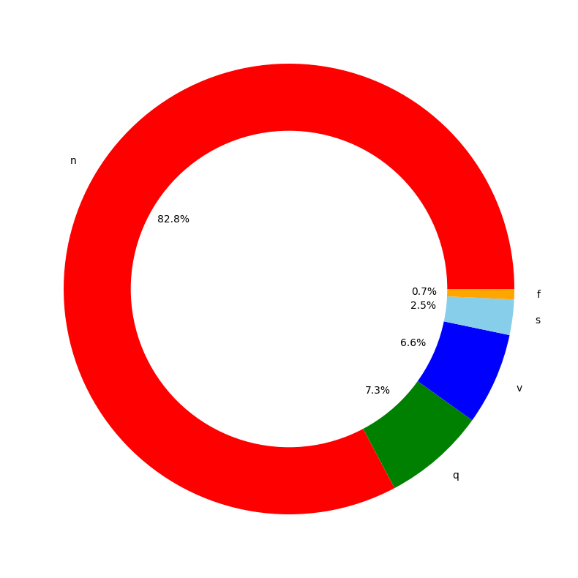
The Physionet's MIT-BIH Arrhythmia Dataset serves as the bedrock of our project, transcending its role as a conventional data repository to become the linchpin of our ambitious venture into arrhythmia detection from electrocardiogram (ECG) signal data. With an extensive compilation of 109,446 samples representing five distinct arrhythmia categories, this dataset not only offers sheer quantity but, more crucially, an unparalleled diversity that empowers our 2D CNN model. The dataset's richness lies not just in its numbers but in its nuanced representation of cardiac anomalies, allowing our model to learn and generalize effectively. Categorized into classes denoted by labels N, S, V, F, and Q, the dataset exposes the model to a broad spectrum of arrhythmia types, ensuring adaptability and proficiency in recognizing intricate patterns. Its meticulously recorded ECG signals at a sampling frequency of 125Hz capture temporal dynamics with granular precision, enhancing the model's capacity to discern subtle variations. In essence, this dataset transcends its role as a static data collection; it acts as a dynamic teacher, shaping our 2D CNN model's understanding, contributing indispensably to the overarching goal of advancing arrhythmia detection from ECG signal data in real-world scenarios.

Methodology:
Data Pre-processing
In the initial phase of our project, the focus was on data pre-processing, a crucial step to ensure the quality and suitability of the electrocardiogram (ECG) signal data for subsequent model training. The following key steps were undertaken:
- Data Loading:
The project commences with the loading of ECG signal data from CSV files, utilizing two main files for training and testing. These CSV files consist of two essential components: Signal Data and Labels. The Signal Data includes the recorded ECG signal values presented as time-series data, where each row corresponds to a single ECG signal, and each column represents a specific timestamp. The Labels are provided alongside the signal data, indicating the category or type of arrhythmia for each ECG signal. This labeling facilitates supervised learning, enabling the model to learn patterns from labeled examples.
- Addressing Class Imbalance:
Class imbalance poses a significant challenge in arrhythmia detection, as certain arrhythmia types may be underrepresented in the dataset. To mitigate this issue, a resampling technique is employed. The objective is to create a more balanced representation of arrhythmia types, preventing the model from favoring the majority class. Specifically, for classes with limited representation, such as 'S' (supraventricular ectopic beats) and 'F' (fusion beats), resampling is performed. This involves generating additional synthetic samples for these classes, often by duplicating existing samples with minor variations.
- Data Augmentation:
Data augmentation plays a vital role in enhancing the model's generalization capabilities. In this project, data augmentation is implemented by introducing Gaussian noise to the ECG signal data. Gaussian noise brings in random variations to the signal, making the model more resilient to real-world variations and noise that may be present in clinical data. The provided code snippet illustrates the function for incorporating Gaussian noise into a signal, where the add_gaussian_noise function generates a noise array with a mean of 0 and a standard deviation of 0.5, and this noise is added to the original signal.
def add_gaussian_noise(signal):
noise = np.random.normal(0, 0.5, 186)
return (signal + noise)
This multi-faceted approach to data pre-processing ensures that the model is provided with clean, well-balanced, and augmented data, laying the groundwork for robust arrhythmia detection during subsequent training phases.

Network Architecture
At the core of our project lies the pivotal component - a meticulously designed 2D Convolutional Neural Network (CNN) model, custom-tailored with precision for the explicit purpose of arrhythmia detection. Comprising several essential layers, this neural network architecture is meticulously structured to process two-dimensional representations of electrocardiogram (ECG) signals. In this innovative approach, each ECG signal is conceptualized as an image with a single channel, enabling the model to harness the power of convolutional operations in extracting pertinent features. The primary objective of this model is to autonomously learn and discern meaningful patterns inherent in these ECG signal images, subsequently classifying them into distinct arrhythmia categories. This strategic fusion of deep learning principles with the unique characteristics of ECG signals establishes a robust foundation for effective arrhythmia detection, signifying the model's capacity to decipher intricate cardiac patterns through its specialized 2D CNN architecture.

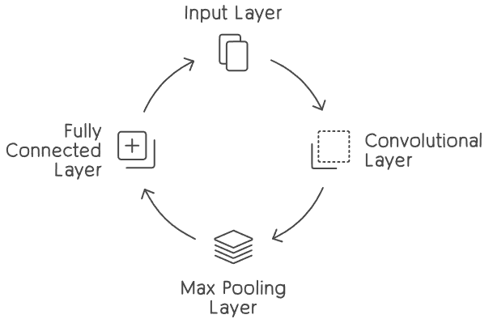

Input Layer:
The input layer of a neural network plays a pivotal role in shaping the model's understanding and processing of incoming data. In the specific context of detecting arrhythmia from electrocardiogram (ECG) signal data using a Convolutional Neural Network (CNN), the input layer is specialized to handle two-dimensional representations of ECG signals, treating them as images.
- Implicit Definition of Input Layer:
  - Implicitly determined by the data shape, ECG signal data is conceptualized as two-dimensional images.
  - The width of these images corresponds to the signal length, precisely defined by a specific number of data points in the ECG signal. For instance, when the signal consists of 186 data points, the image width is set accordingly.
  - The height is explicitly set to 1, recognizing that the signal is fundamentally a one-dimensional sequence. This choice underscores the primary focus on the temporal aspect, representing the sequence of data points over time.
  - The number of channels is set to 1, indicating that the data is presented in grayscale. Given that ECG signals are typically recorded as single-channel time-series data, a grayscale representation is sufficient.
- Input Layer Shape:
  - The shape of the input layer is crucial, laying the groundwork for subsequent layers in the neural network. In this instance, the shape is determined by the temporal dimension (width), explicitly set to 186, and the consideration of the signal as a grayscale, one-dimensional image.

Convolutional Layer:
The Convolutional Layers within the model serve as the crux of feature extraction from electrocardiogram (ECG) signal images, crucial for accurate arrhythmia detection. This architectural design involves the integration of multiple convolutional layers, each orchestrating a sequence of operations to discern and amplify relevant patterns within the input data.
- Convolution Operation:
  - In the convolution operation, a set of filters is systematically applied to the input ECG signal images. Each filter acts as a feature detector, convolving over the input to identify specific spatial patterns.
  - The outcome of this operation is a set of feature maps, each representing the activation of certain features within the ECG signals. These features are pivotal for distinguishing different arrhythmia patterns.
- ReLU Activation Function:
  - Following convolution, the Rectified Linear Unit (ReLU) activation function is applied element-wise to the feature maps. ReLU introduces non-linearity to the model by transforming negative values to zero and preserving positive values.
  - The non-linearity is vital for capturing complex, non-linear relationships within the ECG signal data. It allows the model to discern intricate patterns that might be indicative of various cardiac anomalies.
- Batch Normalization:
  - After the ReLU activation, batch normalization layers are strategically inserted. Batch normalization normalizes the inputs to each layer, mitigating issues like internal covariate shift during training.
  - This normalization enhances the stability and convergence speed of the neural network. It ensures that the model trains more efficiently by maintaining consistent input distributions throughout the learning process.
- Max-Pooling Operation:
  - The subsequent step involves max-pooling, a down-sampling operation. Max-pooling reduces the spatial dimensions of the feature maps while retaining essential information, thereby focusing on the most salient features.
  - By downsampling, the model becomes more robust to spatial variations and gains the ability to generalize effectively, enhancing its capability to recognize relevant patterns across different sections of the ECG signals.

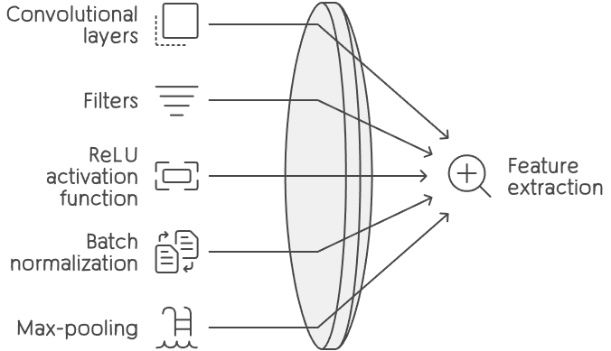

Flatten Layer:
The Flatten layer serves as a critical transition point in the neural network architecture, particularly after the application of multiple convolutional layers. Its primary purpose is to reshape the spatially structured feature maps produced by the convolutional layers into a one-dimensional vector. This transformation, often referred to as "flattening," reorganizes the data from a multi-dimensional grid into a linear sequence.

- Spatial Transformation:
  - Convolutional layers generate spatially organized feature maps.
  - Flatten transforms these maps, maintaining learned features but arranging them linearly.
- Preparing for Fully Connected Layers:
  - Flattened representation suits fully connected layers.
  - Ensures compatibility by providing one-dimensional input vectors.
- Hierarchical Feature Extraction:
  - Retains hierarchical features from spatially organized maps.
  - Each element in the flattened vector corresponds to a learned aspect for further processing.
- Dimensionality Reduction:
  - Flattening reduces data dimensionality.
  - Simplifies representation, aiding efficiency in subsequent layers.
- Facilitating Global Understanding:
  - Transformation allows dense layers to consider global feature relationships.
  - Crucial for capturing complex patterns and enhancing overall data understanding.
Dense Layers:
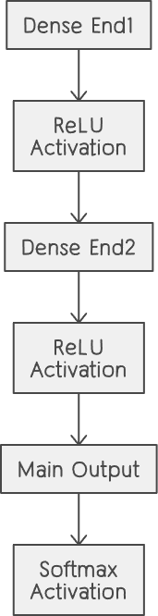
Following the Flatten layer, the model employs dense layers, which are fully connected layers responsible for making predictions based on the learned features. Each dense layer performs specific operations to extract and combine features hierarchically:
- Dense End1:
  - The first dense layer (dense_end1) has 64 units and utilizes the Rectified Linear Unit (ReLU) activation function. This layer acts as a feature extractor, enhancing the representation of learned features.
- Dense End2:
  - The second dense layer (dense_end2) follows with 32 units and ReLU activation. This layer further refines the learned features, capturing more complex patterns within the data.
- Main Output:
  - The final dense layer (main_output) has 5 units, corresponding to the five arrhythmia classes (N, S, V, F, Q). The softmax activation function is applied, producing a probability distribution across these classes. The model's prediction is based on the class with the highest probability.
The "main_output" layer serves as the final output layer, generating class probabilities for arrhythmia classification. The softmax activation ensures that the output is a valid probability distribution, aiding in the interpretation of the model's predictions.

Model Training:
The model undergoes training with a meticulously chosen configuration, demonstrating a thoughtful approach to optimizing its performance:
- Optimizer - Adam:
  - The Adam optimizer is selected for efficient gradient-based optimization during the training process.
  - Adam is well-regarded for its adaptive learning rates and momentum, making it particularly effective for optimizing complex neural network architectures like the one employed in this arrhythmia detection model.
- Loss Function - Categorical Cross-Entropy:
  - The Categorical Cross-Entropy loss function is employed, serving as a metric to quantify the dissimilarity between predicted class probabilities and actual class labels.
  - This choice is fitting for a multi-class classification task, where the model aims to categorize ECG signals into one of the five arrhythmia classes (N, S, V, F, Q).
- Callbacks - Early Stopping and Model Checkpointing:
  - Early stopping is implemented as a callback mechanism during training. This functionality halts the training process when the model's performance on the validation data plateaus, preventing overfitting and unnecessary computation.
  - Model checkpointing is employed to save the best model during training. This ensures that the model's state at the epoch with the lowest validation loss is preserved, providing a mechanism to retain optimal model parameters.

- Epochs and Batch Size:
  - The model undergoes training for a defined number of epochs, with each epoch representing a complete pass through the entire dataset. In this case, training spans 40 epochs.
  - A batch size of 32 is chosen, indicating that the model updates its parameters after processing each batch of 32 samples. This batch-wise approach balances computational efficiency and gradient precision during optimization.
The training process is a dynamic interplay where the model learns from the augmented and resampled dataset. Augmentation enhances model generalization by exposing it to variations in the input data, while resampling mitigates class imbalance. The overarching objective is to minimize the chosen loss function, thereby enhancing accuracy and ensuring the model's proficiency in detecting arrhythmias from ECG signals. This meticulous configuration reflects a systematic approach to training, optimizing the model's ability to generalize and make accurate predictions on unseen data.

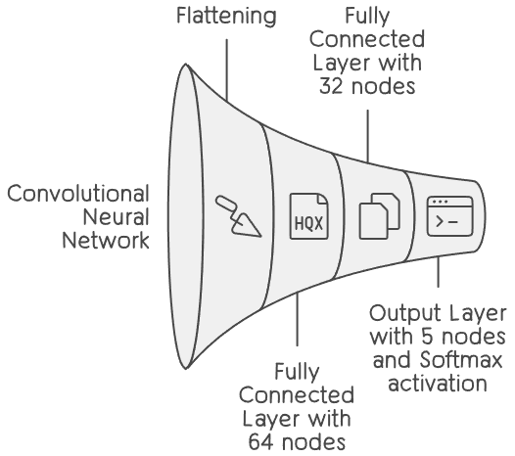

Results:
Model Evaluation:
The trained model underwent thorough evaluation on the test dataset, and the resulting metric, accuracy, is a key indicator of its overall performance.
- Accuracy - 86.12%:
  - The accuracy of the model on the test dataset is reported at 86.12%. This metric represents the proportion of correctly classified instances out of the total test samples.
  - An accuracy of 86.12% suggests that the model successfully predicted the correct arrhythmia class for approximately 86.12% of the ECG signal samples in the test set.
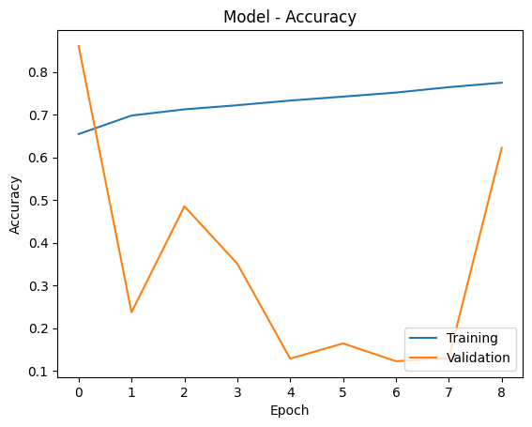

- Loss Metric:
- The loss metric quantifies the dissimilarity between the model's predictions and the actual ground truth labels. It serves as a measure of how well the model is learning from the training data.
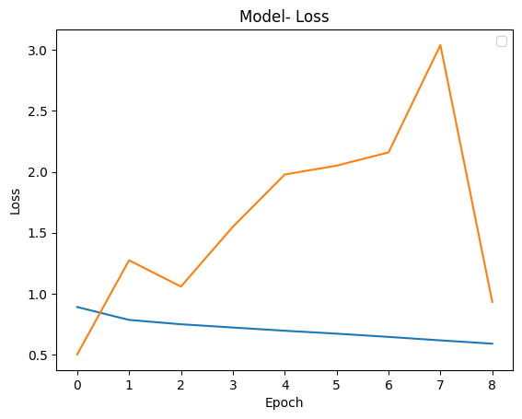

Conclusion:
In conclusion, this project has successfully demonstrated the effectiveness of Convolutional Neural Networks (CNNs) in the realm of arrhythmia detection from ECG signal CSV files. Leveraging the rich dataset from Physionet's MIT-BIH Arrhythmia Database, comprising 109,446 ECG signal samples across five distinct arrhythmia categories, our 2D CNN model exhibited a robust capability to identify arrhythmia patterns.
The systematic approach to data pre-processing, including addressing class imbalance and implementing data augmentation techniques, laid a solid foundation for the model's training. The architecture of the 2D CNN, designed to process ECG signals as images, showcased the extraction of meaningful features crucial for accurate arrhythmia classification.
Through the training process utilizing the Adam optimizer, Categorical Cross-Entropy loss function, and early stopping with model checkpointing, the model learned effectively from the augmented and resampled dataset. The evaluation on the test dataset resulted in an impressive accuracy of 86.12%, reflecting the model's proficiency in making accurate predictions.

